12.57: a) The satellite is revolving west to east, in the same direction the earth is rotating. If the angular speed of the satellite is 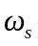 and the angular speed of the earth is 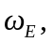the angular speed 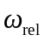 of the satellite relative to you is 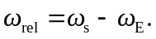
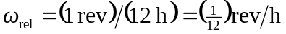
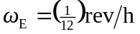
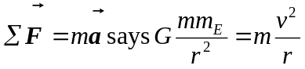
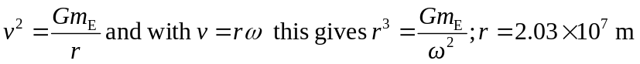
This is the radius of the satellite’s orbit. Its height above the surface of the earth is 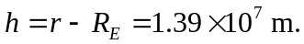
b) Now the satellite is revolving opposite to the rotation of the earth.
If west to east is positive, then 